Step by Step – Electronically Sign with RightSignature
- Locate the email in your inbox from RightSignature (see below)
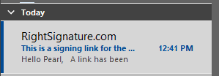

- Open the email and click on the blue box labeled “Review & Sign Document” (see below)
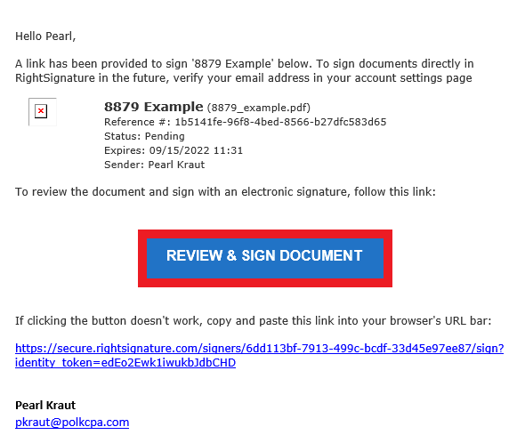

- When the link is clicked, a new window will open with the form(s) that needs to be signed.
  - Scroll down to find the signature box
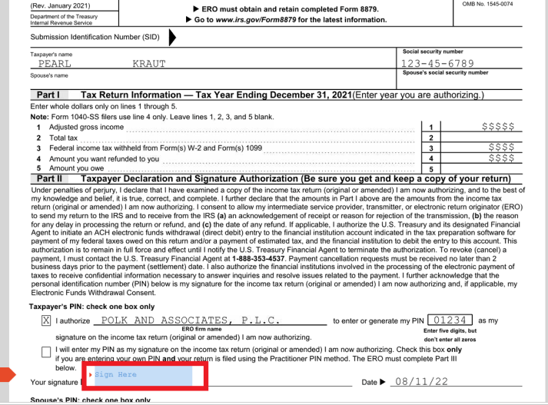

  - Click inside the box
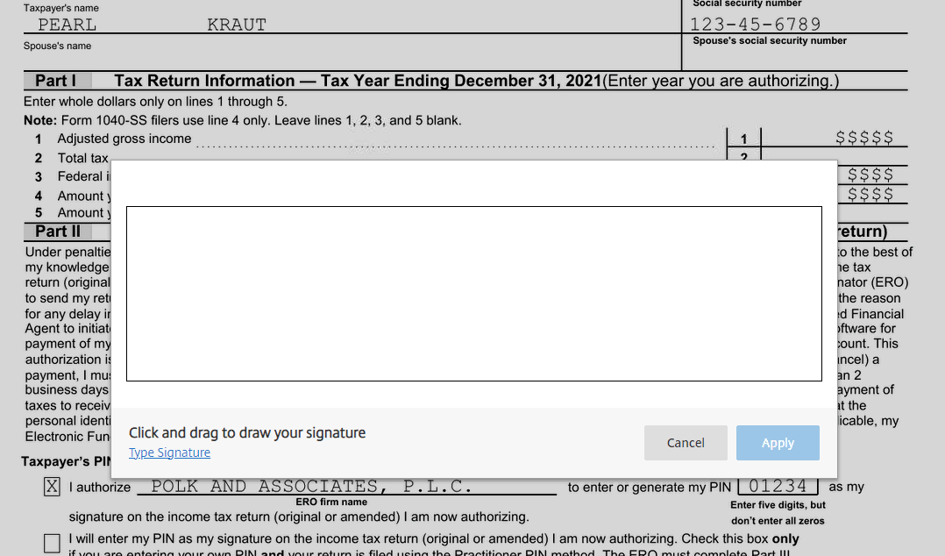
  - Sign your name then click “apply”.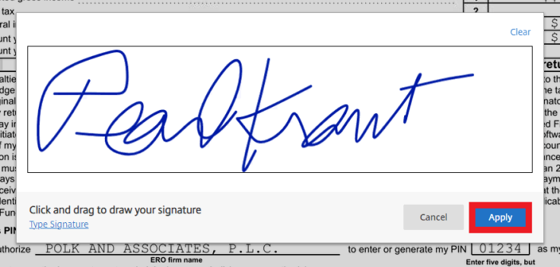

- Next click “Submit Signature”, a new box will open and click “submit” (see below)
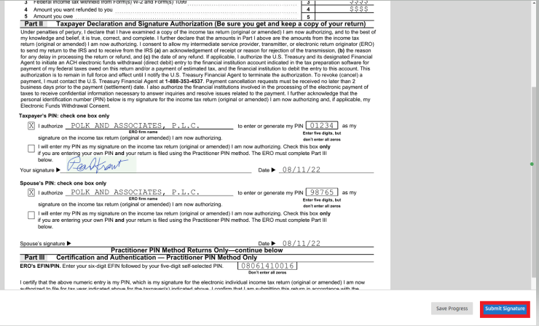
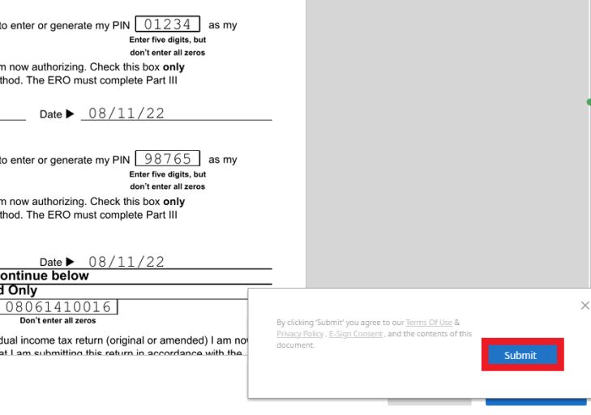

After you click “submit” an email notification will be sent to us and we will handle the rest!

