Step by Step – How to Open ShareFile Email
- Open your email and click the “Download Attachments” box (see below):
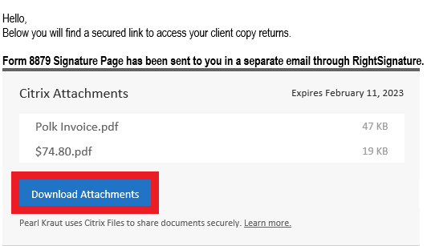

- A new window will open and you will have to enter the following information:
  - Email
  - First Name
  - Last Name
  - Company (if applicable ie: you are receiving a business return).
  - Then you will click continue (as shown below): 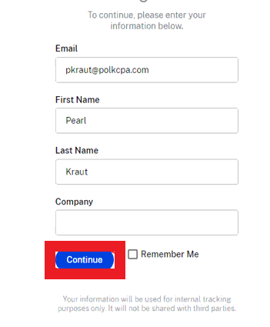

- A new window will load. “Select All” files to be downloaded to your personal computer. Once “Select All” is clicked, click the download button (see below):
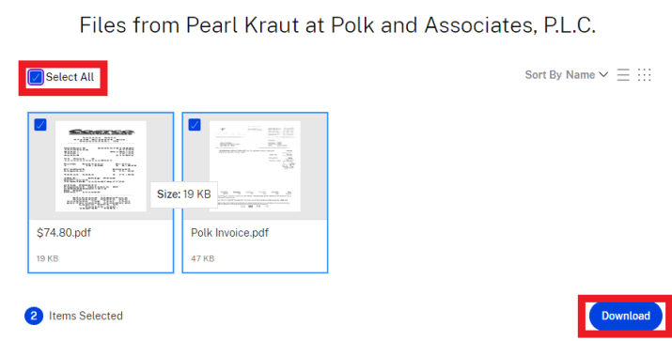

- Once the download button is clicked, a file will be downloaded named “Files.zip” (see below). This will show on the same page where you can select your files.
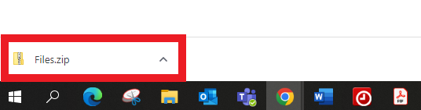

- Right click on “Files.zip” and select the “Show in Folder” option. This will open a new window. This is your downloads folder on your personal computer (see below)
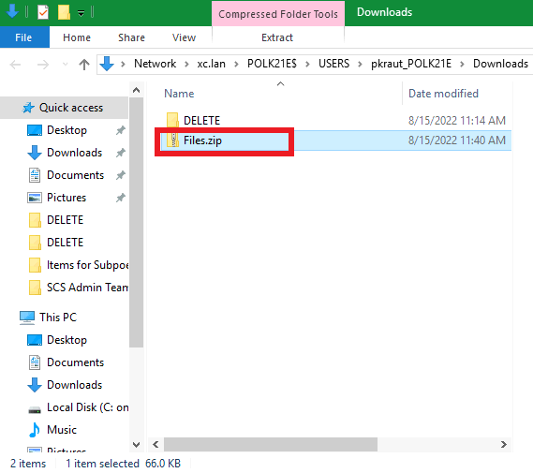

- Right click on the highlighted file (Files.zip) and select Extract All option. This will open a new window and click on the “Extract” option (see below):
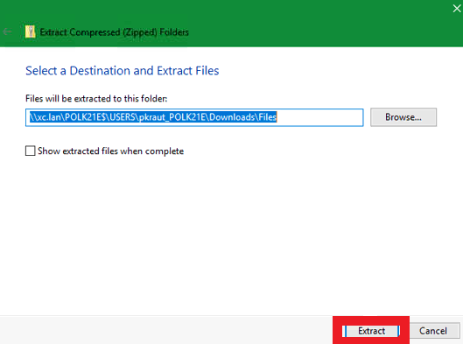

- In your downloads folder (which should still be open) you will now have a new folder called “files”. This is where your documents are currently located.
  - Double click on the files folder (see below)

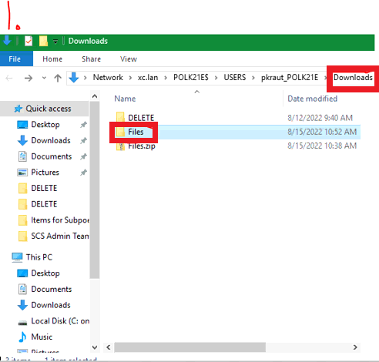
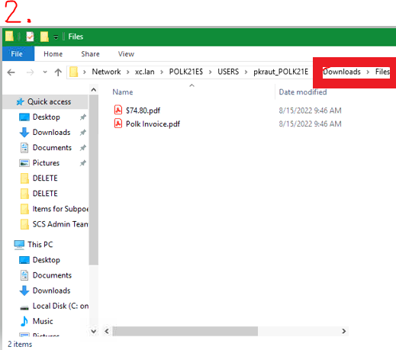

At this point, you may move the documents to a different folder, if you chose. Otherwise you’re all done!

