Step by Step – How to upload to ShareFile

- Locate the email from Polk and Associates with the ShareFile link.

- Click the “click here” link (see below)
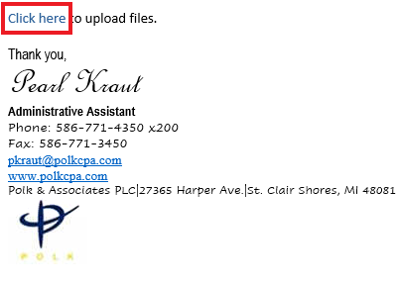
- Once the link is clicked a new webpage will load. Enter the following info, then click the continue button (See below):
  - Email Address
  - First & Last Name
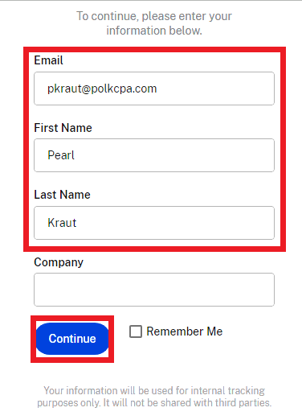
- A new page will load and you can either drag and drop your files into the designated area or click the browse files button to select the files.
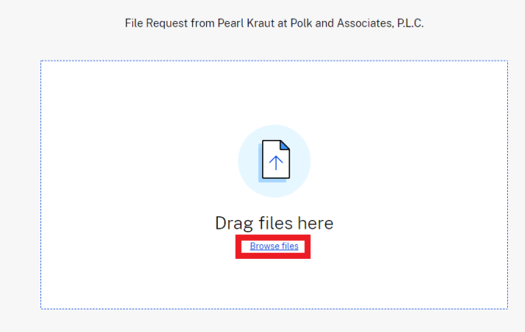

- When all your documents are in the designated area you can hit the upload button
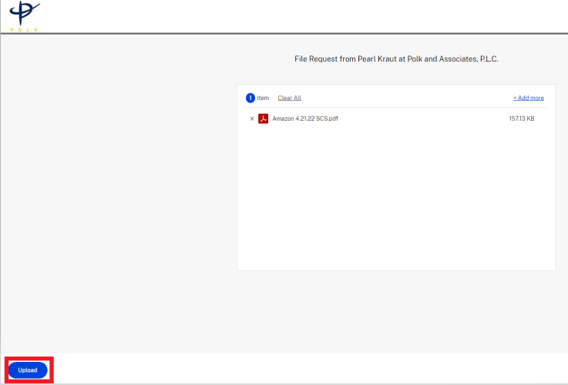
- Once the documents are upload it will look like the below 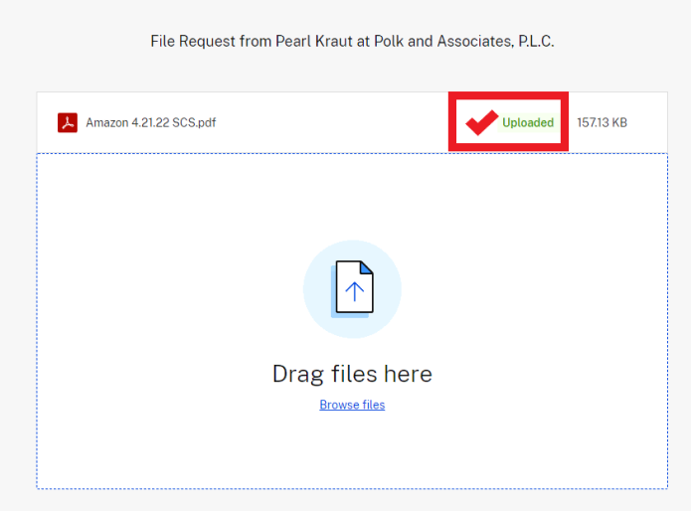

We will receive an email notification on our end letting us know there are new documents to be looked at and you are all set.

**The link that we send is good for 6 months so if you have other docs that need to be uploaded you can do it just like you did these.**

